College Night
  March 1, 2018
  7:00 pm
  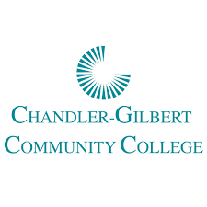
  
  
  
  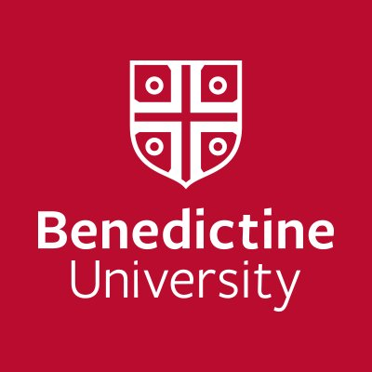
  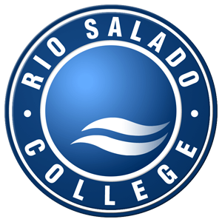
  
  
  
  Come and visit with college and university representatives as they share important information and field questions about the college experience:
  - Admissions
  - Financial Aid
  - Courses of Study
  - Campus Life
  
  A
  8th Grade
  6:30-7:00
  A Representative from Rio Salado College will provide information about our Dual Enrollment Program
  Talk to a Benedictine University Rep to Find out how to earn your bachelor’s degree two years faster than the average student!
  Heritage Academy Gateway
  19705 E Germann RD
  Queen Creek, AZ 85142
  480-461-4400
  hagateway.com
  March 1, 2018

